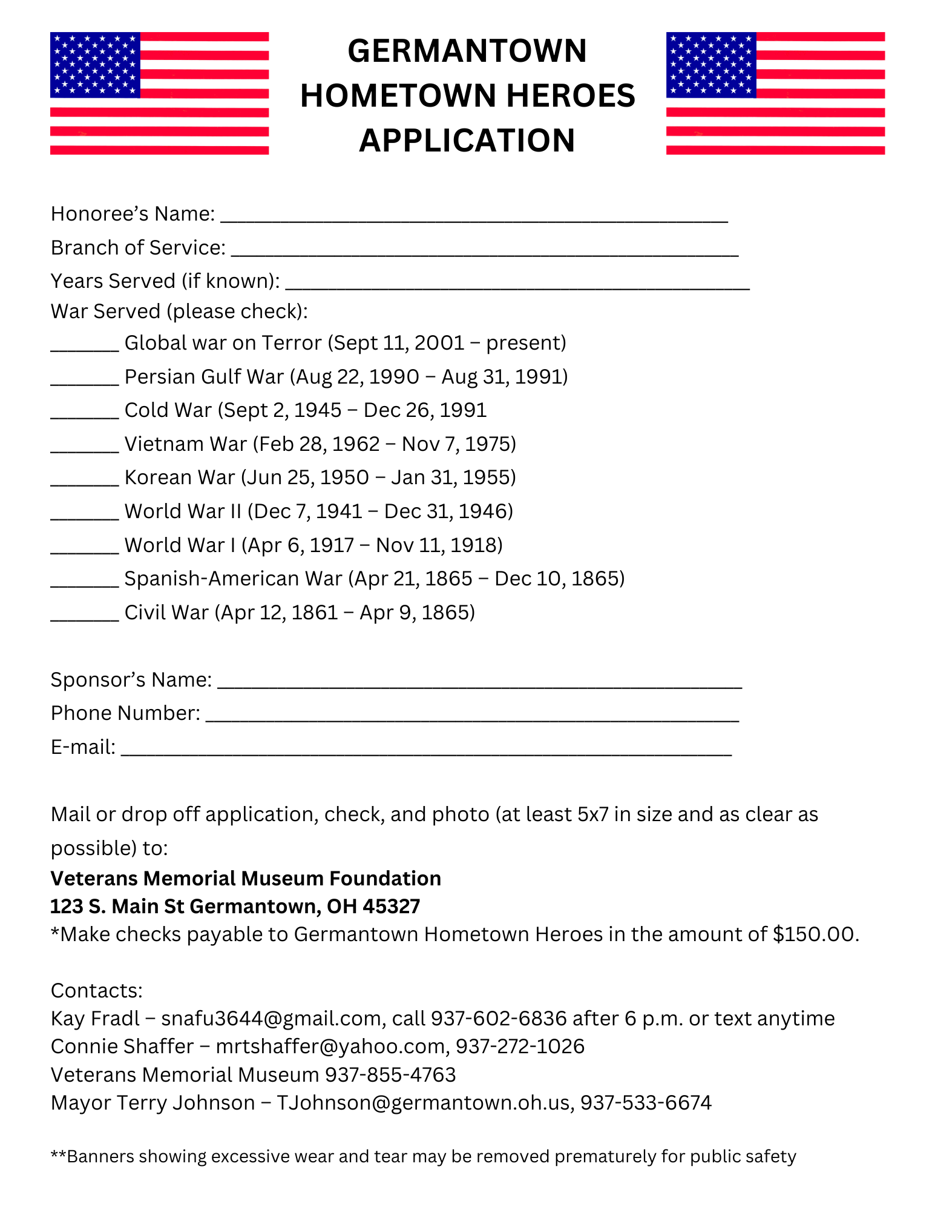

Due by **DECEMBER 27th**2024 to be up for 2025!